**BCSE204P- Design and Analysis of Algorithms Lab**

**E1-Slot-L43-L44 Lab**

**In-Lab Practice (IPS) Exercise-3**

**Name: R. Muhmmad Abrar**

**Register no: 21BRS1713**

**MAX-SUB ARRAY**

**Any Two question Output:**

**Q1).**

Maximum Sum Subarray problem takes an array of positive and negative integers S as input and finds the subarray of S having maximum sum. For example, consider an array with 16 elements, 13, -3, -25, 20, -3, -16, -23, 18, 20, -7, 12, -5, -22, 15, -4, 7. Maximum subarray starts at index 7 and ends at index 10 (programming indices) and sum is 43. Write a C++ code to solve the problem using a naive approach. Print the starting index, end index and sum of the subarray whose sum is maximum. What is the time complexity of the algorithm?

**Code:**

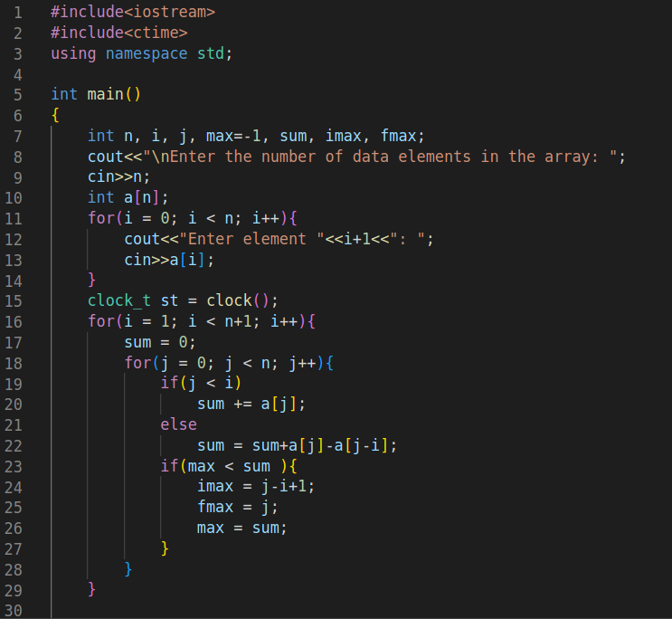

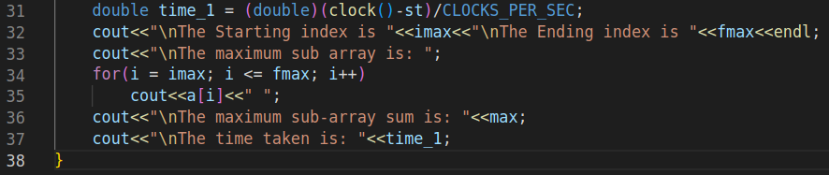

**Output:**

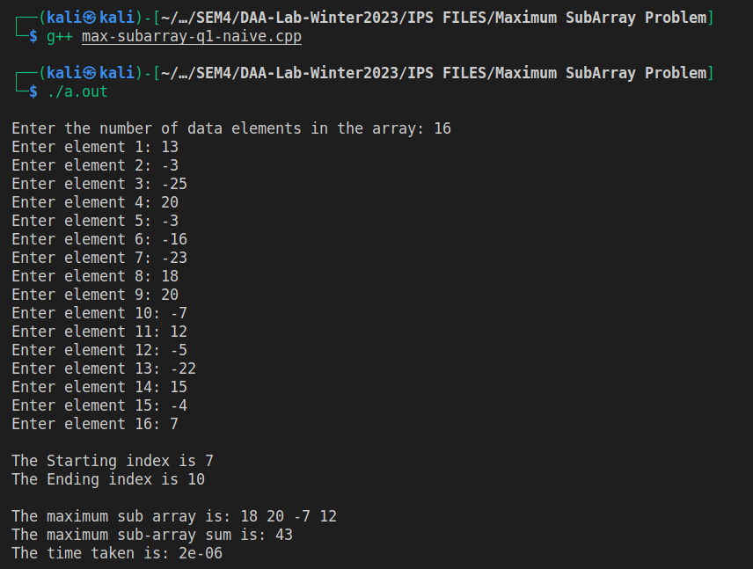

The time complexity of my algorithm is O(n2).

**Q4).**

Given an array of positive and negative integers, develop a linear algorithm and write a C++ code to check if there exist a subarray whose sum is zero is present in it. If such a subarray exist then print start and end index of first occurrence. Otherwise print -1 for both start and end index. For example, if the array contains seven elements 10, -3, 2, 4, -3, 5, 7 then print start index as 1 and end index as 4.

**Code:**

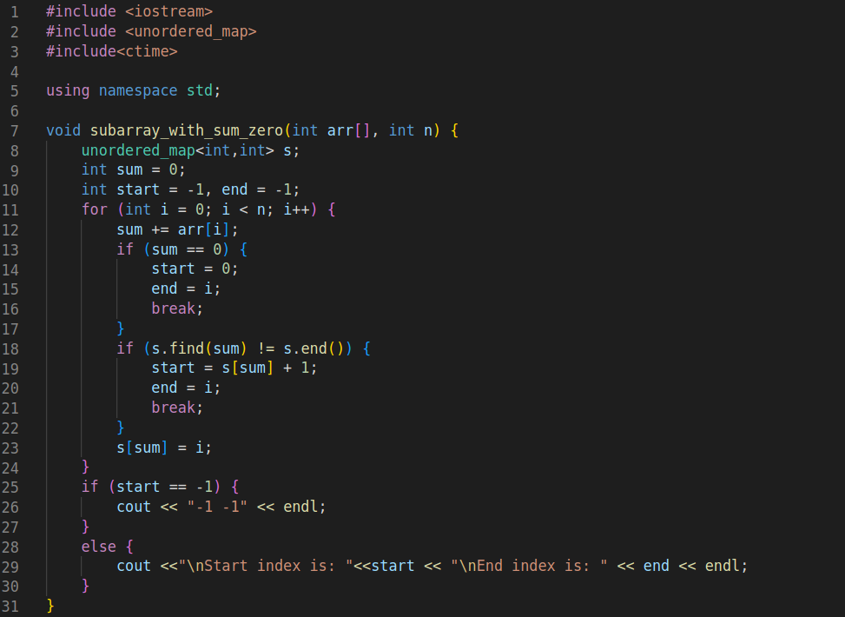

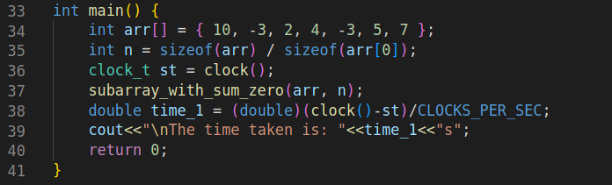

**Output:**

